Instructions: IRB Members and IRB administrators/analysts may utilize this tool as a guidance when reviewing investigator initiated pragmatic (i.e., comparative effectiveness) clinical trials. Utilize this tool in combination with the July 2018 IRB member training slides available online here: https://irb.upenn.edu/mission-institutional-review-board-irb/irb-member-toolbox

Study Necessity / Contribution
- Does the literature review and background support that this study has clinical equipoise? Is there a need for this study to be conducted?

- Is there an appropriate plan for dissemination?

- Does the literature review and background support that this study will contribute to generalizable knowledge?
  - Will the study provide valuable evidence that may benefit future patients?

  - Has all of the literature available been considered? If continuing review is being considered, has recent literature been assessed by the team?

Study Design: Usual Care
- Does the literature review and background appropriately justify that the intervention is usual care? Are more citations or a consultation with an expert necessary?

- Is there a difference in how the usual care intervention is being administered on this protocol compared to usual care outside of the context of this study? (e.g., Has a continuum been bifurcated into groups? Are usual care extremes being compared?)

Study Design: Research Elements
- Does the study involve randomization?

- Does the study involve blinding?

- How controlled is the trial design?
  - Are physicians freely able to use their personal clinical judgement in the patient’s care?

  - Will patients be able to switch treatments during the study?

  - How will this impact the results of the study?

Study Design: Pragmatic versus Explanatory
- On the continuum of explanatory to pragmatic, where does this study lie? Utilize the Pragmatic Explanatory Continuum Indicator Summary (PRECIS) Wheel (Thorpe et al., 2009) https://www.ncbi.nlm.nih.gov/pmc/articles/PMC2679824/. Below is an example of how to complete the wheel. A and C are more pragmatic whereas B and D are more explanatory. E = Explanatory.

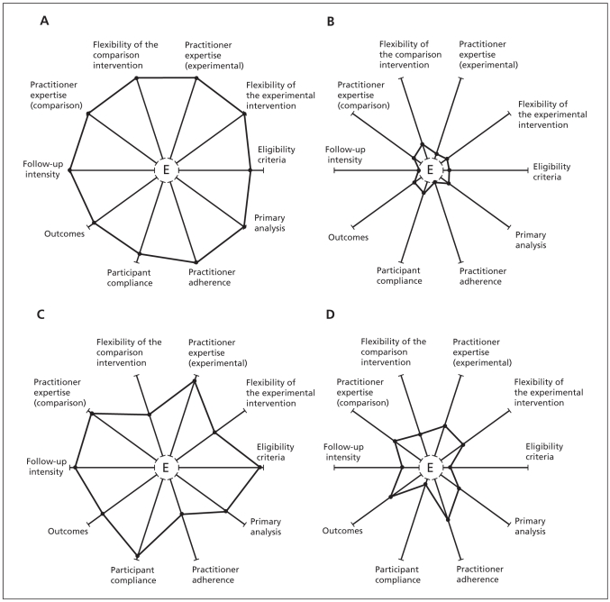

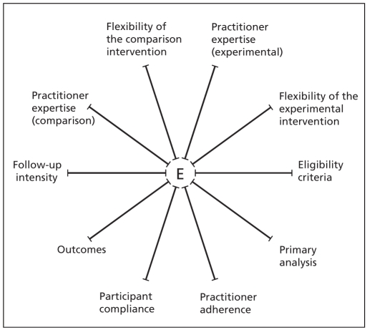

- Based on the review, does the intervention constitute usual care or research? Note: If study is more explanatory and the intervention has been determined to be research, ethical regulations and principles apply to that intervention.

Risks are Minimized / Adequate Provision for Monitoring the Data
- Would interim analysis with a plan to terminate the study be appropriate?

- Does the study require a Data Safety Monitoring Committee or Board to review the study data?

Informed Consent
- Is a full research informed consent process and form necessary?

- If the study is minimal risk and the team is requesting a waiver of consent: Could an alternative consent model such as integrated, targeted, or broadcast consent be considered?

- Should standard care procedures be delineated in the consent form, or would it suffice to refer to a clinical consent form / process?

- Should the risks /benefits of usual care treatments be delineated in the consent form?
  - If not, should a statement be included that notes that it is unknown if the risks /benefits between the two treatments differ?

