This guidance should be used by any physician who wishes to submit to the IRB the use an investigational drug, device or biologic. The below steps are screenshots of how to submit in Penn eIRB. It is strongly recommended that submission to the FDA and IRB occur simultaneously to improve the efficiency of the submission process.

- Sign into Penn eIRB using your pennkey credentials and navigate to “eIRB” Create IRB Protocol. Enter in corresponding information on “Get Started.” For additional guidance on how to complete this page, see “Initial Submissions” slides at: https://upenn.app.box.com/s/iy5xlgu3d7wwlhs0cifqt013or6e15dz. After completion, select “Continue” at the bottom of the page.
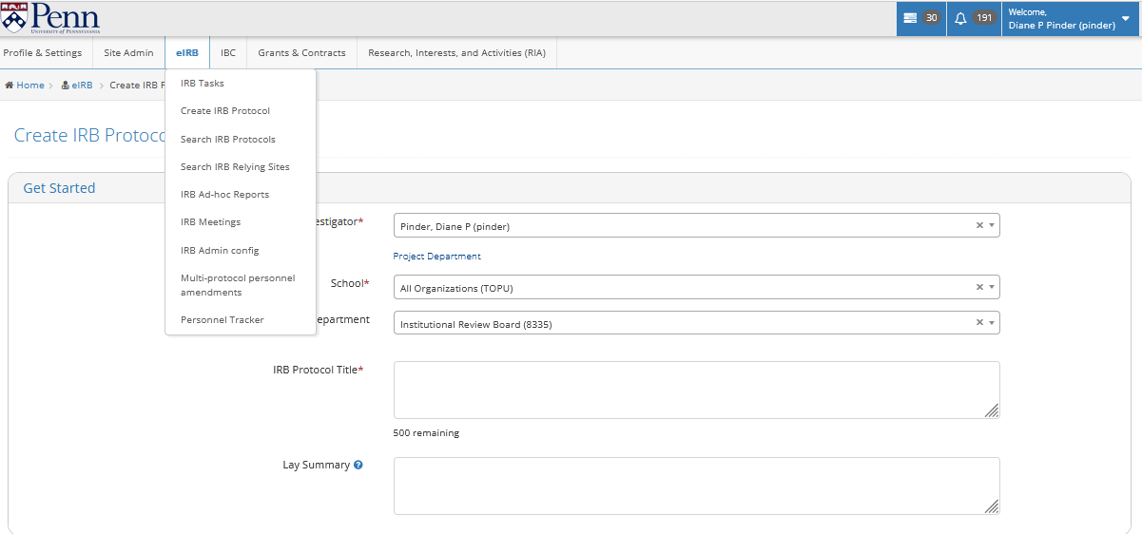
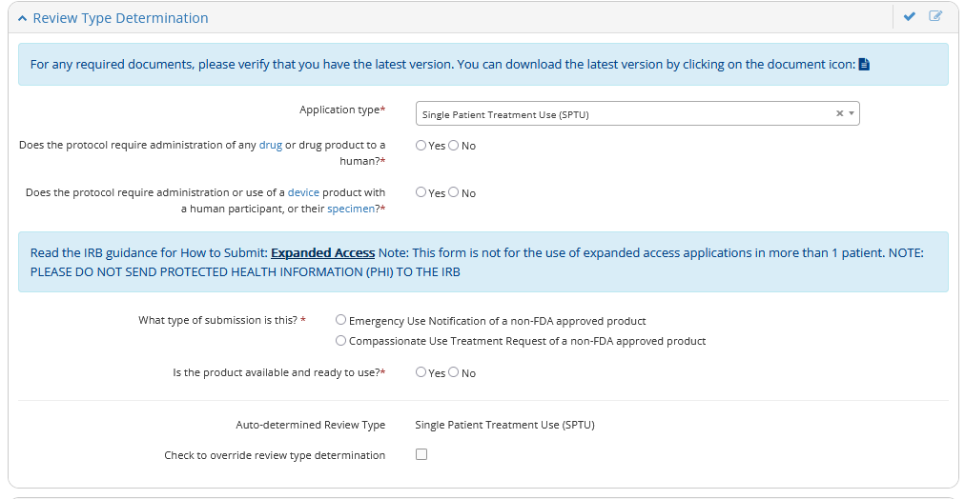
- Under “Review Type Determination” under “Application Type” select Single Patient Treatment Use. This will open up the protocol submission relevant to expanded access. Here you can select if this is an Emergency Use Notification or a Compassionate Use Treatment Request.

- Complete all *red asterisk questions. Ensure you are hitting the “Save” button as you work through the submission as your work is not automatically saved. For guidance on submission, please see the blue banner that reads “How to Submit: Expanded Access”.

Completion Tips:
  - Protocol Description Page
    - For the Anticipated Start Date:
      - Emergency Use: enter the date the product was administered to the patient
      - Compassionate Use: enter the expected/requested date the product will be used
    - Please complete the rest of the sections. If you have a separate word document that was utilized to inform the manufacturer or the FDA that answers ALL of the questions in this section, you may upload that document to this application under “Additional Documents” and reference that document in the appropriate sections. If there is no supplemental document to be uploaded, please ensure all these sections are answered otherwise the application will be returned, delaying review.

  - Informed Consent
    - Emergency Use: Please upload the redacted consent form utilized. No PHI should be sent to the IRB.
    - Compassionate Use: Please ensure you upload the draft consent form (template can be found on the forms page of the IRB website: https://irb.upenn.edu/homepage/formsandtemplates/

  - Sponsored Research Records
    - If the product manufacturer is providing the product to be used, this does NOT qualify as “externally funded.” Select Not Funded if there is no grant or contract associated with this expanded access submission.

  - “Additional Documents”
    - Please upload all applicable related forms. Please see the guidance document for what is required. If any forms are missing without rationale, the submission will be returned. If FDA approval with the IND or IDE is pending, please indicate that in the cover letter, and under “IND” or “IDE” in the Review Type Determination section please note “pending.” If it is approved, add the number. The FDA approval can be uploaded under “Drug Related Documents and Forms” section.
    - A Cover Letter with a document list to be included in the IRB letter should be uploaded under “Other Documents”.
    - If you have a treatment plan document, please upload it in this section.

When you are ready to submit to the IRB, please select “Submit for Approval.”

